OS PROJECT

LINUX BASED WEATHER APPLICATION

SOURCE CODE

weather.sh

#!/bin/bash

API_KEY="65898be33e468b1aa77d16ae10dbd1e7"

BASE_URL="http://api.openweathermap.org/data/2.5/weather"

echo "Enter the city name:"

read CITY

RESPONSE=$(curl -s "${BASE_URL}?q=${CITY}&appid=${API_KEY}&units=metric")

if [[ $(echo "$RESPONSE" | jq -r '.cod') == "200" ]]; then

CITY_NAME=$(echo "$RESPONSE" | jq -r '.name')

COUNTRY=$(echo "$RESPONSE" | jq -r '.sys.country')

WEATHER=$(echo "$RESPONSE" | jq -r '.weather[0].description')

TEMPERATURE=$(echo "$RESPONSE" | jq -r '.main.temp')

HUMIDITY=$(echo "$RESPONSE" | jq -r '.main.humidity')

WIND_SPEED=$(echo "$RESPONSE" | jq -r '.wind.speed')

echo "Weather in ${CITY_NAME}, ${COUNTRY}:"

echo "Description: ${WEATHER}"

echo "Temperature: ${TEMPERATURE}°C"

echo "Humidity: ${HUMIDITY}%"

echo "Wind Speed: ${WIND_SPEED} m/s"

else

[ Read 31 lines ]

^G Help ^O Write Out ^W Where Is ^K Cut ^T Execute ^C Location M-U Undo M-A Set Mark

^X Exit ^R Read File ^\ Replace ^U Paste ^J Justify ^/ Go To Line M-E Redo M-6 Copy

[Cite your source here.]

else

echo "City not found. Please check the name and try again."  
fi

CONTEXT

The provided script is a **bash shell script** for retrieving and displaying weather information for a specified city using the **OpenWeatherMap API**. It begins by prompting the user to enter a city name and sends a request to the OpenWeatherMap API with the provided city name and a predefined API key. The script parses the API's JSON response using the jq utility to extract relevant weather data, such as the city name, country, weather description, temperature, humidity, and wind speed. If the city is found, the weather details are displayed in a user-friendly format. In case of an invalid city name or an error response from the API, the script displays an appropriate error message. This script demonstrates basic interaction with APIs, error handling, and working with JSON in bash.

OUTPUT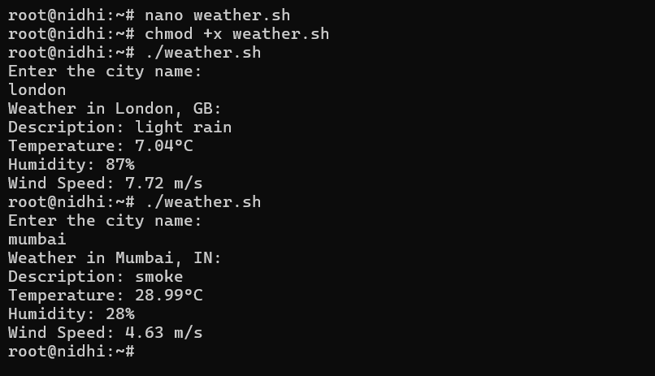

So these are the real time weather updates from different cities

TEAM MEMBERS

L.S.V.S.RAMA KRISHNA - AP22110010663

A.HARSHA – AP22110010710

D.NAGA SRINIDHI – AP22110010712